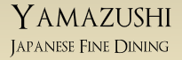
Premium Saké Tasting Evenings

Japanese saké has a thousand year history, and a rich variety of brewing methods and regional tastes. Do you normally have wine with Japanese cuisine? Getting to know saké can be an adventure that's as exciting and rewarding as exploring the many varieties and qualities of wine. Learn some of the key concepts of saké to appreciate the difference. Taste and compare the flavor paired with Japanese cuisine prepared by famed Yamazushi chef, George Yamazawa

We hope that you will join our saké adventure together!

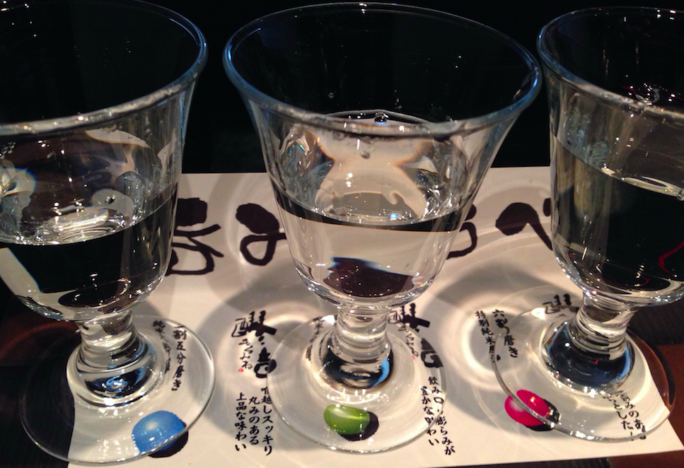

CALENDAR (all start at 7:00. See program details on the next page)
June 17, Wed What is premium saké?
June 24, Wed Varieties of Saké

COST: $40 per session excluding tax and tip

CONTACT: sakedurham@gmail.com or call 919-265-3585

Each session will run for about one hour and a half, starting with a brief presentation from which you will learn about saké, followed by a tasting of 4 premium sakes with matching small plates.

Programs

June 17: What is premium saké?
Shima will introduce the basics of saké-making. She will discuss rice varieties and other ingredients that go into the brewing process; describe the fermentation process and how the brewer controls flavor; and introduce the various qualities of sake and the Japanese classification system. The program will then move to a tasting of some of the varieties of premium sake.

June 24: Varieties of Saké
We will taste saké brewed by more traditional methods that rely on natural fermentation using a longer brewing cycle. In addition to traditional brew, we will taste nigori. Nigori saké is unfiltered and has a cloudy or milky appearance. Although this variety of saké has often been perceived as rough and unsophisticated, it is increasingly being appreciated for its personality and flavor contrasts.

The program may change without prior notice.

酒 酒 酒 酒 酒 酒 酒 酒 酒 酒 酒 酒

About Saké Durham
Saké Durham conducts saké tasting events and server training. The goal of Saké Durham’s tasting events is to help participants discover the fresh and superb qualities of premium saké for those who enjoy fine foods. Our tasting club is designed to suggest new food pairings with and beyond the traditional Japanese cuisine.

Saké Durham founder Shima Enomoto was born and raised in Tokyo, and has more than 20 years experience in finance at top global investment banks, most recently as Managing Director at Mitsubishi UFJ Securities in New York. She received her MBA from Columbia Business School and has worked in Tokyo and New York. Over the years, she has explored her passion for saké and wine by taking classes and going to tastings in Japan, US and Europe. She recently relocated to Durham, North Carolina where her husband is a professor at Duke University.

Shima realized that fresh premium saké is still hard to find in the Triangle even though Durham has become a “foodie” town, and she decided to share the joy of saké with fellow foodies in the area. She is an Advanced Saké Professional (ASP) certified by the Saké Education Council, and a “Kikizakeshi” (Saké Sommelier) certified by the Food and Beverage Organization of Japan.

