Saké Tasting @ Waraji

Produced by Saké Durham

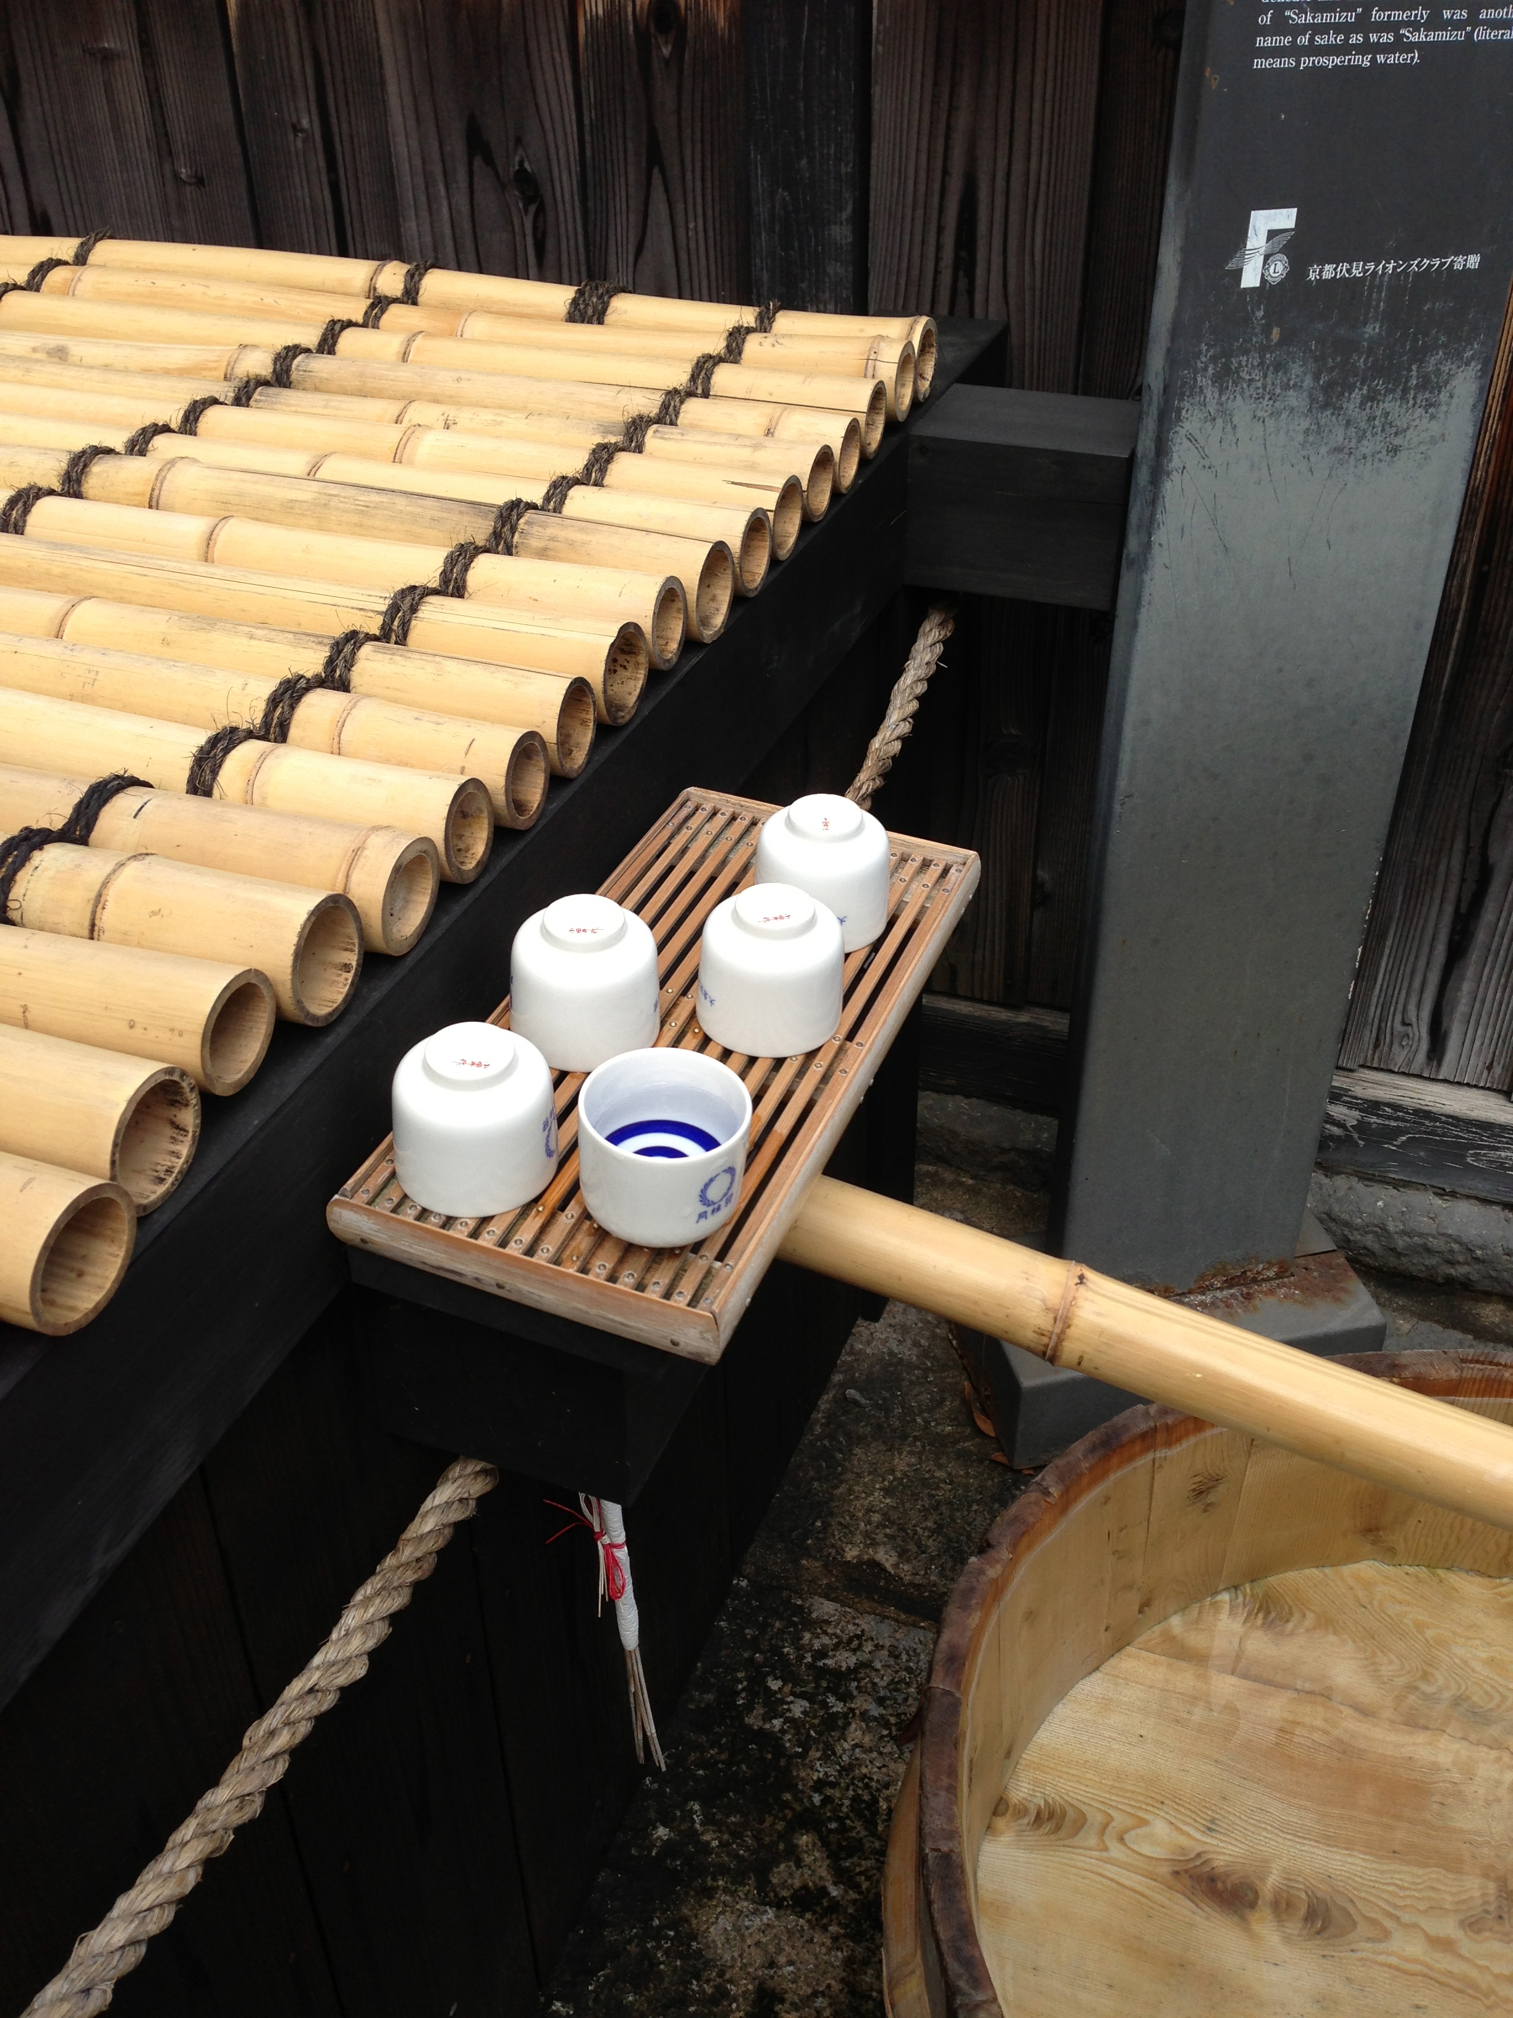

Would you like to learn more about saké? Here is an opportunity to learn about and taste different styles of saké, paired with special little treats prepared by the Chef Masa at Waraji. The program will be introduced by saké sommelier Shima Enomoto.

CALENDAR (all start at 6:30. Please see the next page for details for each program)
February 3, Tues Traditional methods of saké making
February 17, Tues Nigori Night! Exploring unfiltered sakés
March 10, Tues Regionality

COST: $40 per session

CONTACT: sakedurham@gmail.com or call 919-265-3585

Each session will run for about one hour, starting with a brief presentation from which you will learn how saké is made and other saké facts, followed by a tasting of 3 or 4 premium sakés. If you prefer to stay after the program, you can order dinner (and more saké!) from Waraji’s regular menu.

Prior experience is not necessary. Just bring your curiosity and readiness to enjoy the world of saké. Please join us in our saké adventure @ Waraji!

- Traditional methods of saké making ~ February 3
In this program, we will go a little deeper into the saké brewing process. We will compare modern brewing processes with the more traditional methods that rely on natural fermentation using a longer brewing cycle. We will compare and contrast the flavors of some premium sakés with an emphasis on traditional brewing methods.

- Nigori Night! Exploring unfiltered sakés ~ February 17
Nigori saké is unfiltered and has a cloudy or milky appearance. Although this variety of saké has often been perceived as rough and unsophisticated, it is increasingly being appreciated for its personality and flavor contrasts. You will find some Nigori are not sweet and food friendly. We will explore the brewing process for nigori, and taste some brands noted for their individual flavor and texture.

- Regionality ~ March 10
In this program, we will explore the differences between the sakés of different areas of Japan. These traditions date back to a time when local brewers were fiercely proud of their regional flavors, which were often developed to match the varieties of local cuisine. We will pair premium sakés of Japan’s Inland Sea, Japan Sea, and central mountain areas with selected regional tidbits to give you a taste of this rich variety.

The program may change without prior notice.

About Saké Durham
Please visit sakedurham@wordpress.com

Saké Durham conducts saké tasting events and server training. The goal of Saké Durham’s tasting events is to help participants discover the fresh and superb qualities of premium saké for those who enjoy fine foods. Our tasting club is designed to suggest new food pairings with and beyond the traditional Japanese cuisine.

Saké Durham founder Shima Enomoto was born and raised in Tokyo, and has more than 20 years experience in finance at top global investment banks, most recently as Managing Director at Mitsubishi UFJ Securities in New York. She received her MBA from Columbia Business School and has worked in Tokyo and New York. Over the years, she has explored her passion for saké and wine by taking classes and going to tastings in Japan, US and Europe. She recently relocated to Durham, North Carolina where her husband is a professor at Duke University.

Shima realized that fresh premium saké is still hard to find in the Triangle even though Durham has become a “foodie” town, and she decided to share the joy of saké with fellow foodies in the area. She is an Advanced Saké Professional (ASP) certified by the Saké Education Council, and a “Kikizakeshi” (Saké Sommelier) certified by the Food and Beverage Organization of Japan.

